# **CHALLENGE – 03**

1. **Write a bash script to find the latency from the sample nginx log file.**

**Bash script should only only print the latency.**

* File (log_test.csv) copied from windows to linux

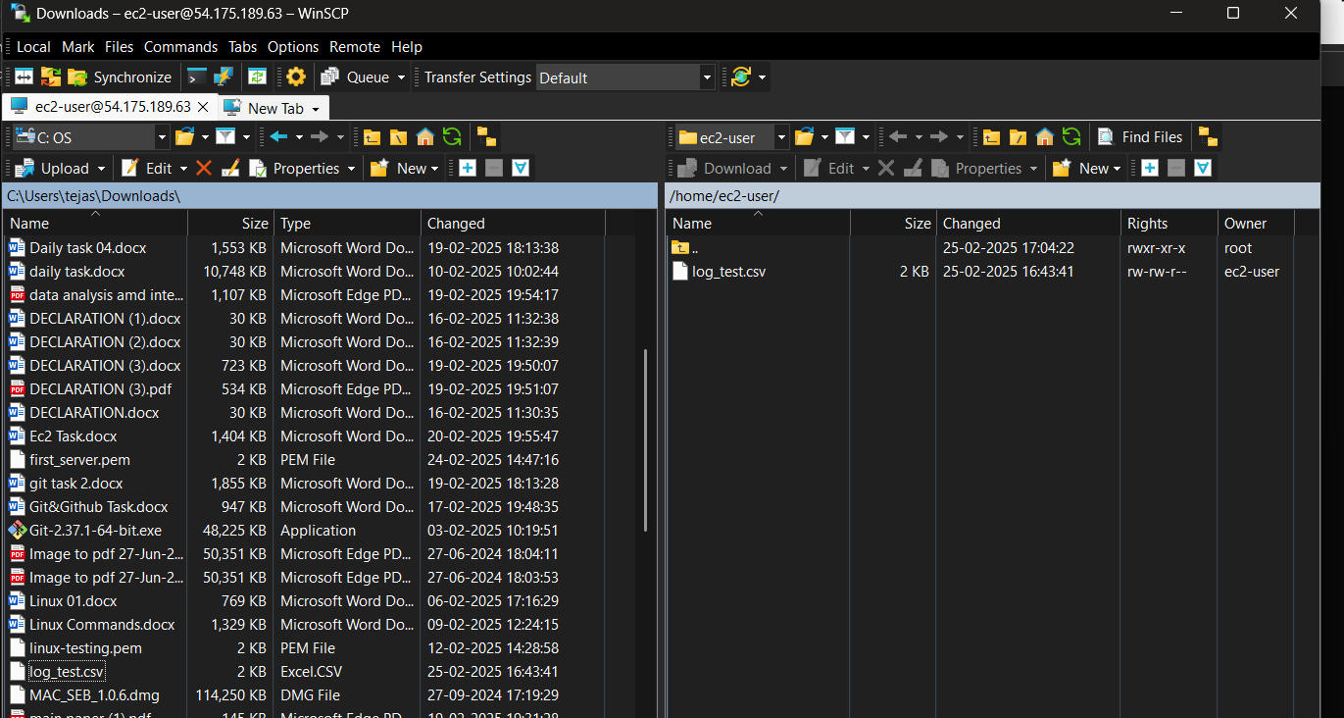

Script used to print

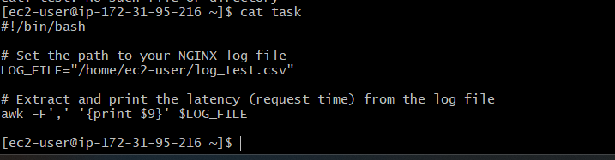

Output

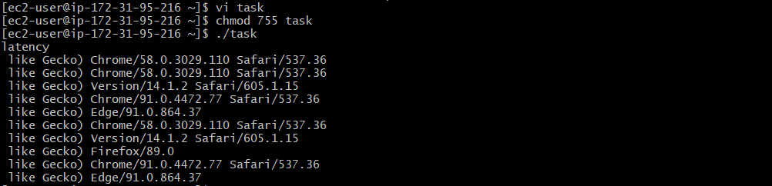

2.   Bash Script to create repo in github

* Script used to create the repo

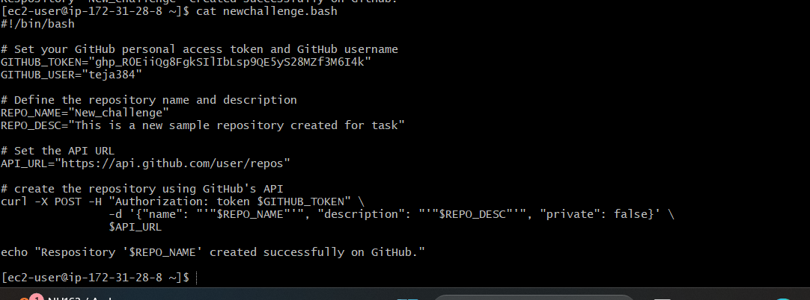

Output : new repo has created with name New_challenge in GitHub

